Name: Fagorala Nifemi Oluwatosin

Student ID: 20454177

Index No: 3156920

Programme: Mechanical Engineering

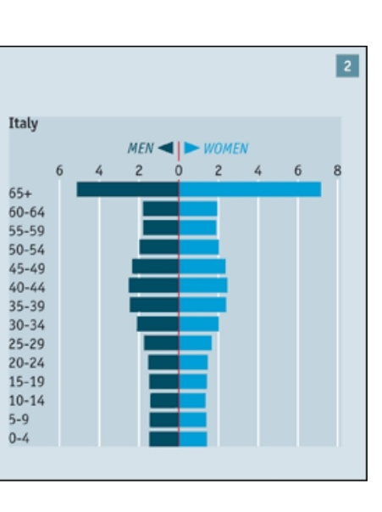**ENVIRONMENTAL STUDIES ASSIGNMENT 1**

Using the information given the above graph the death toll of Italy from the disease was very high because a relatively larger amount of the population was within the age group of 65 and above meaning that a relatively huge part of the population was susceptible to the disease.

1. The most important thing to prepare for as a population increases is the scarcity of resources, which varies from food to healthcare, education and much more because as the population gradually reaches its carrying capacity the harder it will be to provide adequately for all members of that society.
2. KNUST has passed its carrying capacity which has been estimated to be about 700/sq km ( ref: bartleby.com) .
3. **How to avert the situation** :

* Raising the requirements to gain admission into the school.
* Establishment of school halls/ hostels off campus to reduce on campus residents.
* Usage of E- learning platforms e.g zoom, google classroom to reduce the number of students attending classes physically.

1. **Major impacts of agricultural society:**

* They learned how to use fire for land clearing
* They engaged in monocropping
* They began to manage large flocks of animals.